## **Project Report**

**Course:** CO2214**:**

Practical work on CO2224

**Group Number/Name:** Group 12

**Student IDs:**

EUSL/TC/IS/2021/COM/71

EUSL/TC/IS/2021/COM/34

EUSL/TC/IS/2021/COM/75

EUSL/TC/IS/2021/COM/48

EUSL/TC/IS/2021/COM/93

EUSL/TC/IS/2021/COM/61

## 

## 

## 

## 

## 

## **1. Project Overview**

● **Project Title:** WhatsApp

● **Project Type:** Mobile App

● **Domain:** Messenger

● **Brief Description:**

* **Text Messaging** – Send and receive instant messages.
* **Voice and Video Calls** – Make high-quality voice and video calls.
* **Group Chats** – Create and manage group conversations with multiple participants.
* **Media Sharing** – Share images, videos, documents, and voice notes.
* **Status Updates** – Post temporary text, images, or videos that disappear after 24 hours.
* **End-to-End Encryption** – Ensures secure and private communication.

● **The user**:

* General Users
* Students & Educators
* Communities & Organizations

## 

## 

## 

## 

## 

## 

## **2. Data Collection And Data Analysis**

## **Forms response chart. Question title: 1.Would you like the option to make poll votes anonymous (so no one can see who voted what)?  . Number of responses: 51 responses.**

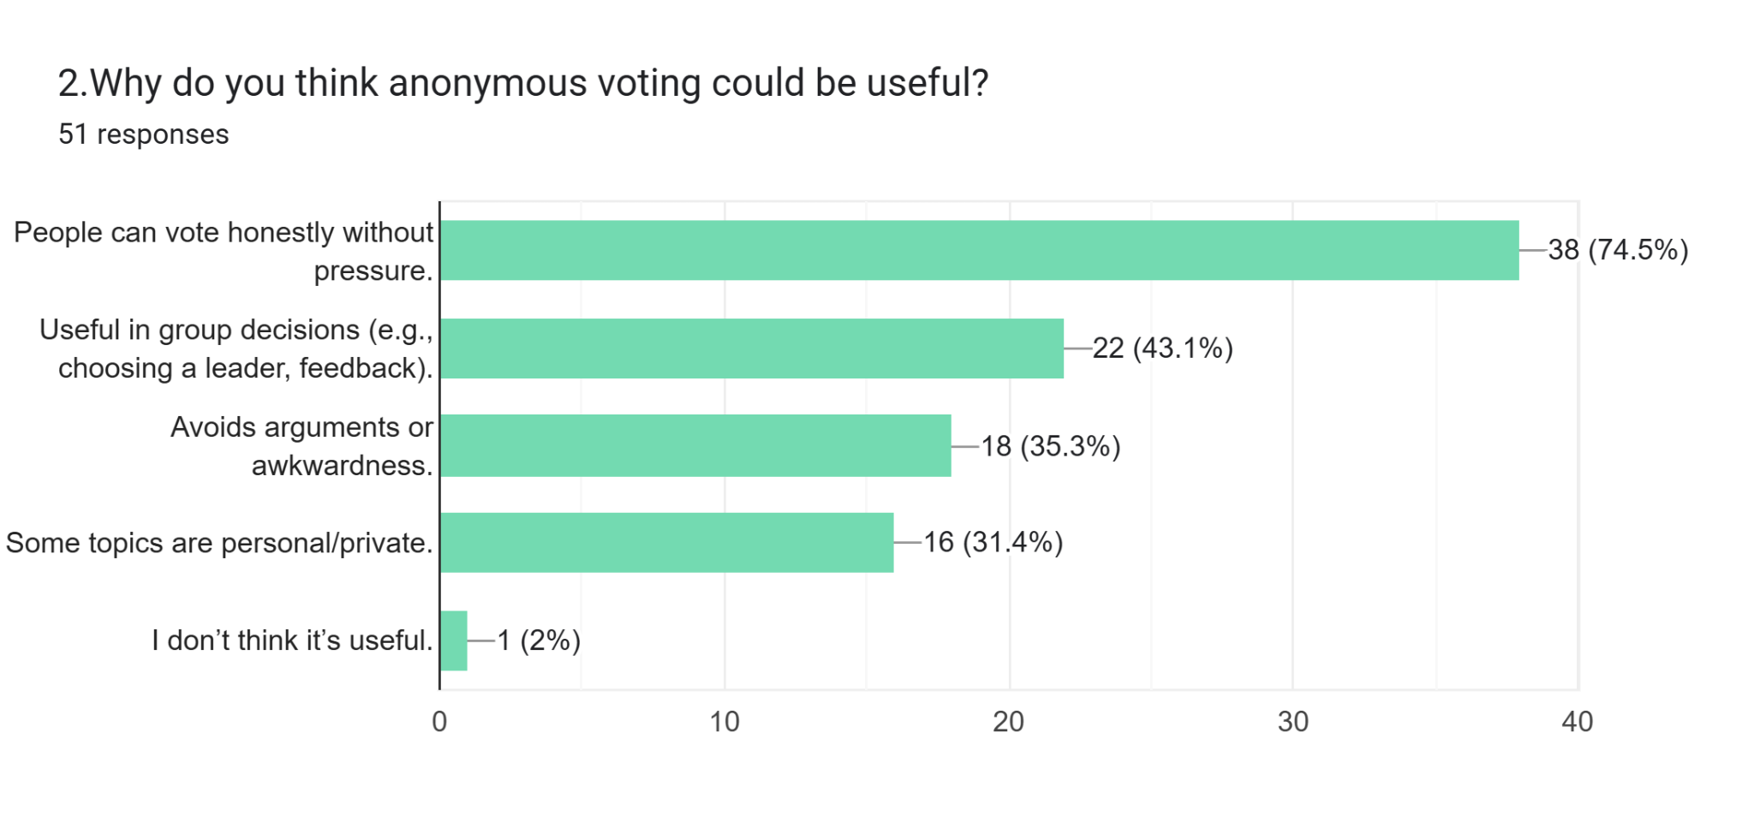**Forms response chart. Question title: 3. WhatsApp Poll Time Limitation
(This feature would allow you to set a time limit for polls. After the time ends, people can’t vote anymore.)
Would this feature be useful to you?. Number of responses: 51 responses.**

## **Forms response chart. Question title: 4. If poll time limitation is added, how likely are you to use it when creating a poll?. Number of responses: 51 responses.**

## **Forms response chart. Question title: 5.WhatsApp Scheduled Messages (This feature would let you type a message now but choose a future time and date for it to be sent automatically.) Would this feature help you?. Number of responses: 51 responses.**

## **Forms response chart. Question title: 6.In what situation do you think scheduled messages would be useful? (You can choose more than one). Number of responses: 51 responses.**

## **Forms response chart. Question title: 7.Whatsapp Ghost mode Would you find a Ghost Mode button (to quickly turn off last seen, read receipts, and online status) helpful? . Number of responses: 51 responses.**

## **Forms response chart. Question title: 8.Which of the following options would you like to have in a Ghost Mode feature? (Select all that apply). Number of responses: 51 responses.**

## **Forms response chart. Question title: 9.If WhatsApp adds a Ghost Mode button, where should it appear?. Number of responses: 51 responses.**

## **Forms response chart. Question title: 10.WhatsApp Airplane Mode (This feature would stop all WhatsApp messages and calls temporarily, but you can still use the internet for other apps.) Would this help you when you need a break from WhatsApp?. Number of responses: 51 responses.**

## **Forms response chart. Question title: 11.When would you most likely use Airplane Mode in WhatsApp?. Number of responses: 51 responses.**

## **Forms response chart. Question title: 12. Green Dot/Light Near Profile (Online Status) (This feature would show a small green light next to a person’s profile picture when they are online — similar to how it appears in Facebook Messenger.) Would you like WhatsApp to have this feature? . Number of responses: 51 responses.**

## **Forms response chart. Question title: 13.If WhatsApp adds a green light to show when someone is online, what would you prefer?. Number of responses: 51 responses.**

## Google Form

## <https://docs.google.com/forms/d/e/1FAIpQLSeK25JG9yAyL22SjoQvxoBCwkGkKk2-KpvpHS-g1GBYtrILeA/viewform?usp=header>

Responses

## <https://docs.google.com/forms/d/e/1FAIpQLSeK25JG9yAyL22SjoQvxoBCwkGkKk2-KpvpHS-g1GBYtrILeA/viewform?usp=header>

## 

## 

## 

## 

## 

## 

## 

## **3. Identifying Design Flaws & Gaps**

**I) Whatsapp Polls**

● **Evaluation Criteria:** User control and freedom

● **Usability Issues Identified:**

Lack of Anonymity **-** Users cannot choose to make their votes anonymous, leading to privacy concerns.

No Expiry Time Control - Users cannot set an expiration time for polls, leading to indefinite open polls.

● **User Experience Problems:**

Privacy - Votes are visible to all poll participants. Users may feel uncomfortable voting honestly.

Decision Making Delays- Users may continue voting long after a decision should have been made. Leads to confusion and delays in finalizing group decisions.

● **Screenshots & Examples:**

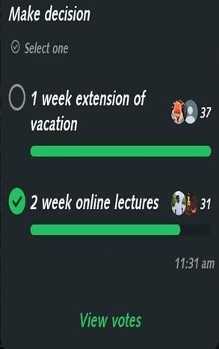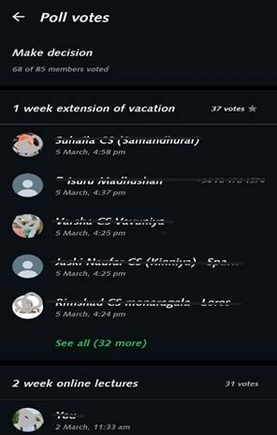

● **User feedbacks**:

* "I want to vote anonymously, but WhatsApp doesn’t allow it."
* "Would be nice to have a poll that expires after a set time."
* "I accidentally voted on an old poll thinking it was new. An 'Expired' tag would help."

**II) Schedule Message**

* **Evaluation Criteria:** Visibility of System Status, User control and freedom
* **Usability Issues Identified:**

#### No Built-in Message Scheduling - WhatsApp currently doesn’t offer a native option to schedule messages for future delivery.

#### Manual Workarounds - Users rely on third-party apps or set reminders to manually send messages at a later time.

#### Lack of Control - No integrated feature exists that allows users to manage time-based message delivery.

* **User Experience Problems:**
* Inefficiency – Users must remember to send messages at specific times, leading to missed communications.
* Workarounds Required – Businesses and individuals use external tools, complicating workflows.
* Uncertainty – Without confirmation, users may doubt whether a message was scheduled correctly.

● **Screenshots & Examples:**

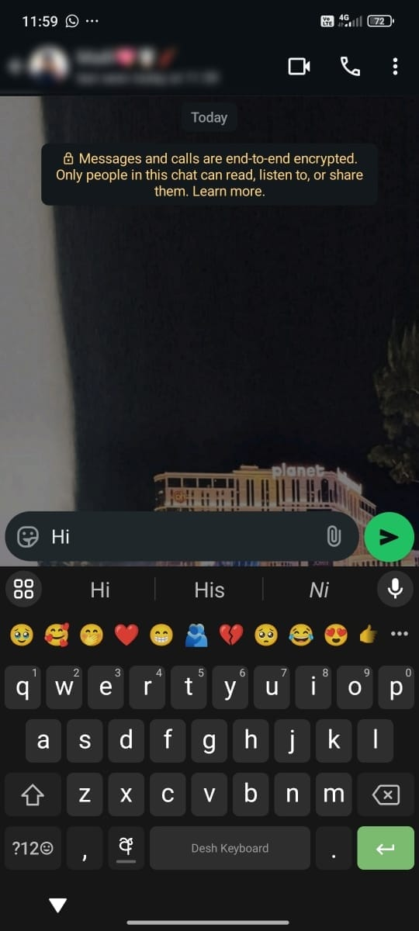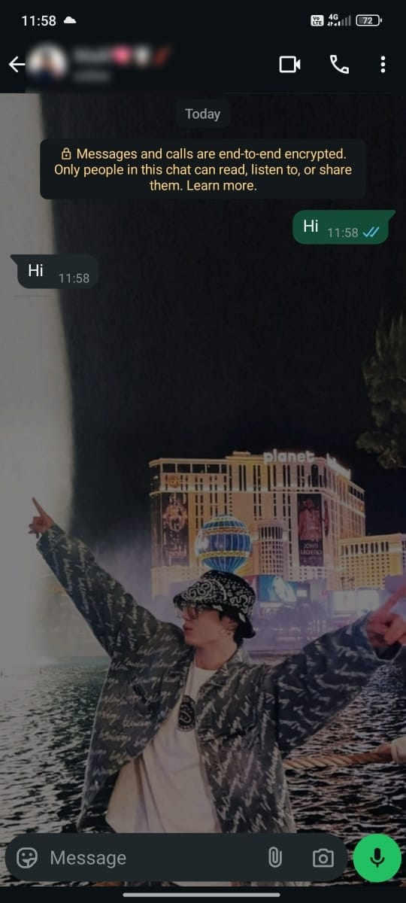

● **User feedbacks**:

* “Sometimes I want to wish someone at midnight but I always forget.”
* “Telegram lets me schedule messages. WhatsApp should too.”
* “I need to follow up with someone tomorrow but I don’t want to forget — scheduling would help.”

## 

## 

## 

## 

## 

## 

## **III) Active Status Feature in WhatsApp**

**Evaluation Criteria:** Visibility of System Status, User Control & Freedom

**Usability Issues Identified:**

* ·  **No Profile-Level Online Indicator -**

WhatsApp currently does not show online status directly on the profile pictures in the chat list or status list. Users must open a chat to see if someone is online.

* **Inefficient Visibility -**

It's difficult to know at a glance who is online, especially when managing multiple contacts or conversations.

**User Experience Problems:**

* **Time-Consuming –**

Users need to open each individual chat to check if someone is online.

* **Lack of Awareness –**

Users cannot casually scan the chat list to see who is available for instant communication.

**User Feedback:**

“Now I can see when my friends are online, so I know when it’s a good time to message.”

“I like the green dot—it makes the app feel more connected, like Instagram or Messenger.”

“Knowing someone is active helps me feel confident they’ll respond soon. Great for quick updates.”

## 

## 

## **IV) Flight Mode in WhatsApp**

* **Evaluation Criteria:** Visibility of System Status, User Control & Freedom.

### **Usability Issues Identified:**

**1.Lack of Status Awareness** – Contacts don’t know if a user is intentionally unavailable (e.g., flying, in meetings, etc.).  
2.**No Quick Disconnect Option** – There’s no one-tap way to temporarily pause all incoming activity without going offline or changing settings manually.  
3.**No Availability Signaling** – Users can't signal their limited or non-availability without being misinterpreted as ignoring messages.

### **User Experience Problems:**

**Interrupted Focus or Sleep**

* + Users get disturbed by messages even when they want to be offline or undisturbed on WhatsApp only.
  + Unlike apps like Telegram or Instagram, WhatsApp lacks flexible notification control or custom quiet hours.
* **Usability Benefits:**

**1.Clear Communication** – Contacts are aware you're not currently active or available.

**2.Reduced Distractions** – No calls or messages interrupting your focus time.

**3.User Control** – Easily toggle on or off from Settings > Privacy > Status Control.

* **User Feedback :**

## “I get so many WhatsApp messages during work hours—it’s hard to focus without going completely offline.”

* “Right now, I use airplane mode on my phone just to get peace from WhatsApp. It feels extreme.”
* “WhatsApp is essential, but sometimes it’s too ‘always-on.’ I wish I could control when I’m available.”

## **V) Ghost Mode**

* **Evaluation Criteria:** User control and freedom
* **Usability Issues Identified:**
* **Lack of Clarity in Mode Activation:** Users may not always know when Ghost Mode is activated or whether it is functioning as expected due to the lack of a clear visual indicator.
* **No Flexibility in Invisible Actions:** While Ghost Mode makes users' actions invisible to others, users cannot choose to hide specific activities, such as their Last Seen or read receipts, independently.
* **User Experience Problems:**
* **Privacy and Perception Issues:** Although Ghost Mode enhances privacy, it might cause concerns about isolation or deliberate ignoring, as others may think the user is avoiding their messages.
* **Lack of Control:** Users may want to toggle specific actions like "Last Seen" visibility or read receipts, but Ghost Mode does not allow for this granularity, leading to frustrations.
* **Confusion and Uncertainty:** Without clear communication about when Ghost Mode is active, users might be unsure of their visibility, which can lead to confusion when interacting with others.

## **User Feedback:**

* "Ghost Mode is great when I need some privacy and don’t want to be disturbed."
* It’s nice to check messages without the pressure to respond right away.

## **4. HCI-Based Design Improvement Suggestions**

**I.Whatsapp Polls**

**Proposed Improvements:**

**01.Privacy Improvements (User Control & Freedom, Visibility of System Status)**

**Anonymity Toggle:**

* Allow users to choose whether their votes are public or anonymous.
* Implement a **"Vote Anonymously"** toggle before submitting a response.
* Aligns with **user control & freedom** by giving voters privacy options.

**Custom Vote Visibility:**

* Provide **three visibility levels**:

o **Public:** Everyone sees votes.

o **Limited:** Only the poll creator sees results.

o **Anonymous:** Only final percentages are visible, not individual votes.

* Enhances **flexibility & efficiency** in user interactions.

**02. No Expiry Time Control (Flexibility & Efficiency of Use, Visibility of System Status)**

**Poll Expiry Timer:**

Allow users to **set a closing time** when creating a poll:

**Options:** 1 hour,6 hours, 1 day, 1 week, or custom.

**Default Setting:** "No expiry" unless manually changed.

**Custom Vote Visibility:** Provide **two visibility levels**:

**Public:** Everyone sees votes.

**Anonymous:** Only final percentages are visible, not individual votes.

Enhances **flexibility & efficiency** in user interactions.

● **Recommended Usability Fixes:**

| **Issue** | **Usability Fix** | **HCI Principle Applied** |
| --- | --- | --- |
| Lack of Anonymity | Add an anonymity toggle for votes. | User Control & Freedom |
| No Expiry Option | Introduce poll closing time settings. | Flexibility & Efficiency |

● **Interaction Improvements:**

**Poll Status Indicator:**

Show labels on polls.

Helps users quickly see whether a poll is still accepting votes.

**II.Schedule Message**

**Proposed Improvements:**

1. Long Press the Send Button – Opens a quick popup with the option “Schedule Message”.
2. Choose Date & Time – A clean, dark-themed time picker allows users to choose when the message should be sent.
3. Tap “Send at [time]” – Confirms and schedules the message

| **Issue** | **Usability Fix** | **HCI Principle Applied** |
| --- | --- | --- |
| No native scheduling | Add long-press to schedule messages. | User Control & Freedom |
| No time-based control | Include date-time picker UI | Visibility of System status |

● **Interaction Improvements:**

**S**end Button Enhancements:

* Long press reveals popup with a single option: Schedule Message

Schedule Picker

**Undo Option:**

* Allow users to cancel scheduled messages before sending.

## **III. Active Status Feature in WhatsApp**

**Proposed Improvement:** Green Dot for Active Status, Green Dot on Profile Picture

A small green dot will appear on the bottom-right corner of a user’s profile photo in:

* Chat list
* Group participant list
* Status viewer

This dot will only appear when the user is currently online.

**HCI Principles Applied:**

| **Issue** | **Usability Fix** | **HCI Principles Applied** |
| --- | --- | --- |
| No quick visibility of online users | Add green dot on profile picture | Visibility of System Status |

**Interaction Design:**

**1.** The green dot will fade in/out smoothly when someone comes online or goes offline to avoid distractions.

2. No additional tap or hover needed — it’s a passive visual cue.

3. Controlled via privacy settings (optional):

4. “Show my active status to: Everyone / My Contacts / Nobody”

**IV. Flight Mode Feature in WhatsApp**

**Proposed Improvements:** Flight Mode allows users to temporarily disconnect from WhatsApp without going fully offline or blocking contacts. When activated:

* **Airplane Mode Toggle in Settings** – Lets users disconnect WhatsApp from the internet without affecting other apps.
* **Choose Duration** – A clean, time picker allows users to set how long Airplane Mode remains active (e.g., none.15 min, 1 hour, custom).
* **Auto Reconnect** – At the end of the set time, WhatsApp reconnects automatically, and a status message is shown to inform the user.
* Users will **not receive messages, calls, or online status visibility** while in Flight Mode.

### **Usability Issue & Fix**

| **Issue** | **Usability Fix** | **HCI Principle Applied** |
| --- | --- | --- |
| No quick way to pause communication | Add Flight Mode toggle on whatsapp | User Control & Freedom |
| No time based disconnect | Include duration time | Visibility of system status |

### **Interaction Design Details**

1. **Airplane Mode Toggle:**

A simple on/off switch added under Settings → Privacy or Notifications

1. **Duration Picker:**

When turned on, users can choose:

* 15 min, 30 min, 1 hour, or set custom duration
* Option to **manually turn off anytime**

**3.Status Indicators:**

* In-app Banner:  
   “🛫 Airplane Mode is ON – WhatsApp is temporarily offline”

**Behavior in Flight Mode:**

* No message or call notifications are delivered.
* User appears offline and inactive.Messages are queued and delivered after exiting Flight Mode.

**V. Ghost Mode**

### **• Proposed Improvements:**

#### **01. Privacy & Visibility Enhancements *(User Control & Freedom, Visibility of System Status)***

**Ghost Mode Toggle:**

* Add a dedicated ghost icon next to the search bar on the main screen.
* Tapping the icon opens a description popup explaining Ghost Mode.
* Users can tap **“Activate”** to turn it on or **“Cancel”** to exit.

**Visual Feedback:**

* In **Light Mode**:  
  + Inactive = **white** ghost icon
  + Active = **black** ghost icon
* In **Dark Mode**:  
  + Inactive = **black** ghost icon
  + Active = **white** ghost icon
* Offers clear, real-time feedback on Ghost Mode status.

**Status Description Box:**

* Displays clear information about Ghost Mode:  
   *“While Ghost Mode is active, your actions are invisible to others. Last Seen is frozen, opened messages won’t show double ticks, and statuses can be viewed secretly.”*

### • Recommended Usability Fixes:

| Issue | Usability Fix | HCI Principle Applied |
| --- | --- | --- |
| No clear status feedback | Use dynamic icon color changes to indicate mode state | Visibility of System Status |
| No user control for activation | Add ghost icon with on/off toggle and confirmation popup | User Control & Freedom |

● **Interaction Improvements:**

**Mode Feedback:**

* Clearly show when Ghost Mode is active through the color of the ghost icon.

**Activation Popup:**

* Simple interface with "Activate" and "Cancel" buttons to prevent accidental enabling.

**No Expiry Confusion:**

* Since Ghost Mode stays active until manually turned off, system avoids unnecessary complexity.

**Theme Adaptability:**

* Icon colors automatically adapt to system theme (light/dark) ensuring visibility and consistency

|  |  |  |
| --- | --- | --- |
|  |  |  |
|  |  |  |

## **5. Redesigned Prototype in Figma**

**I.Whatsapp Polls**

● ***Overview of the New Design:***

The redesigned WhatsApp poll feature introduces two key improvements based on user feedback and identified design gaps:

1. **Anonymous Voting** – This feature allows users to vote privately without revealing their choices to others, encouraging honest participation.
2. **Poll Time Limitation** – Users can now set a time duration for polls (e.g., 30 minutes, 6 hours, 1 day, or a custom time). This ensures that decisions are made within the intended timeframe, preventing late or irrelevant responses.

These enhancements aim to improve user trust, reduce peer pressure, and support efficient group decision-making.

● ***Wireframes & Mockups:***

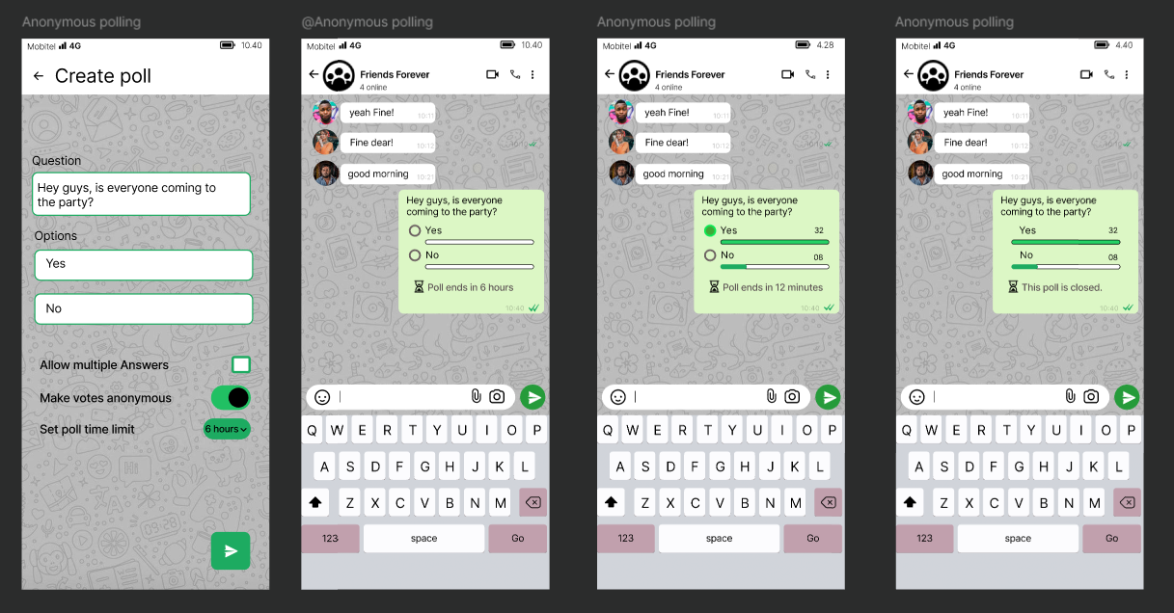

● ***User Flow Diagram:***

**User Journey for Creating a Poll:**

1. Open group chat
2. Tap on "Poll"
3. Enter question and options
4. Toggle **Anonymous Voting** (optional)
5. Set **Time Limit** (optional)
6. Submit poll
7. Members vote → System tracks time → Results shown or poll closed

**User Journey for Voting in a Poll:**

1. Receive poll in chat
2. Tap choice
3. If anonymous: Vote is submitted privately
4. If time expired: Poll shows closed message

● ***Prototyping Features Used in Figma:***

* **Interactive Components**: Toggle buttons for enabling/disabling anonymous mode
* **Overlays**: Used to simulate dropdown for setting poll time
* **Smart Animation**: Smooth transitions between poll creation, live poll, and result view
* **Device Frames**: Used mobile mockups for real-device feel
* **Prototype Links**: Connected screens to demonstrate full user flow for usability testing

**II.Schedule Message**

● ***Overview of the New Design:***

The redesigned **“Scheduled Message”** feature in WhatsApp enables users to compose a message and schedule it for future delivery through a simple, intuitive flow. The design integrates seamlessly with WhatsApp’s current user experience and follows key **HCI principles**:

* **Visibility of System Status**: A **clock icon** replaces the usual tick icons to indicate that the message is scheduled. Users can check the scheduled status in the message info panel.
* **User Control & Freedom**: Users can cancel the message before it is sent.
* **Consistency & Familiarity**: The feature reuses WhatsApp’s native UI patterns and interaction methods (e.g., long-press actions, info panel) to maintain familiarity.

● ***Wireframes & Mockups:***

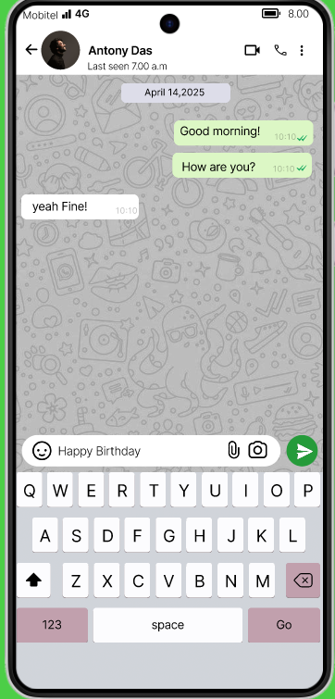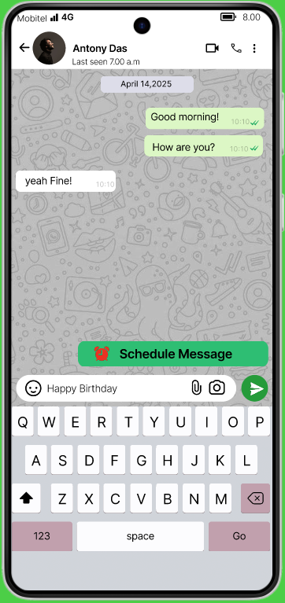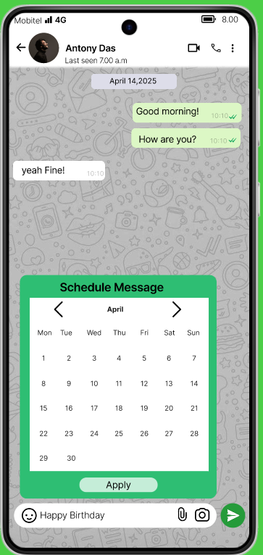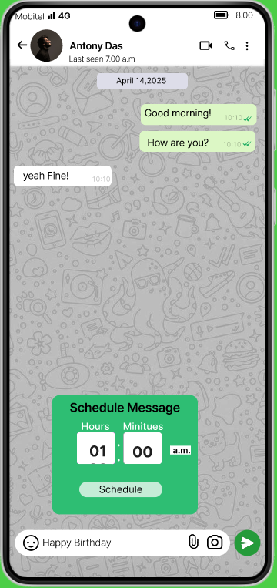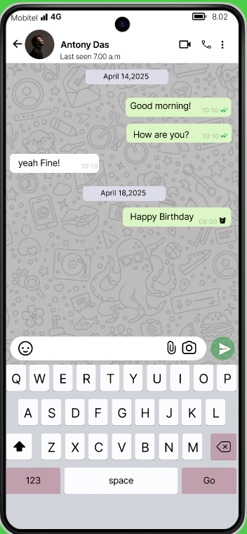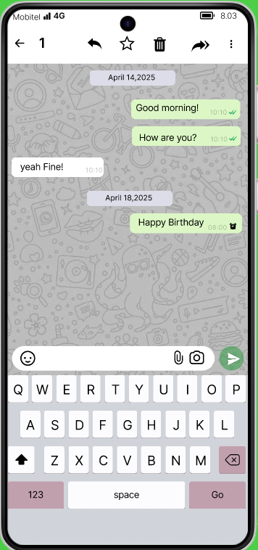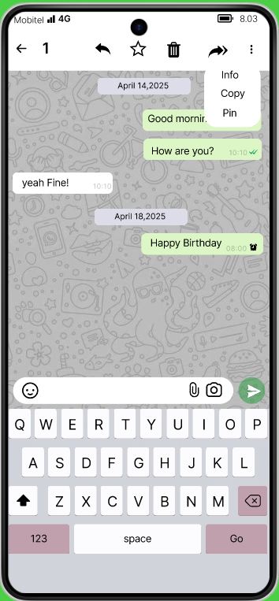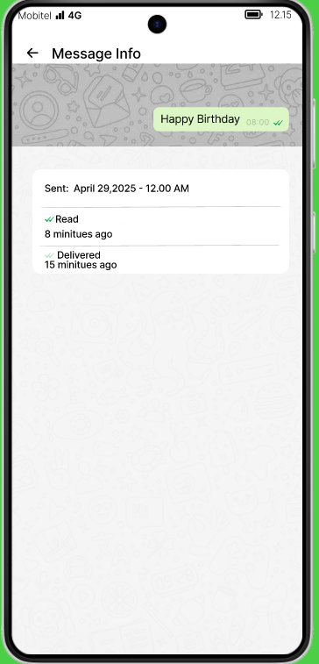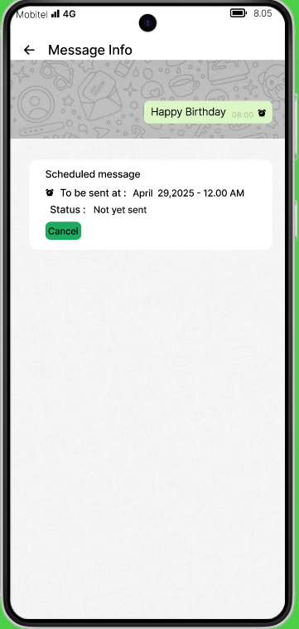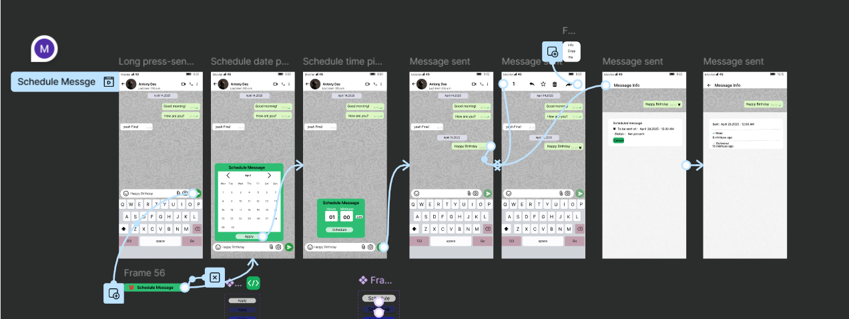

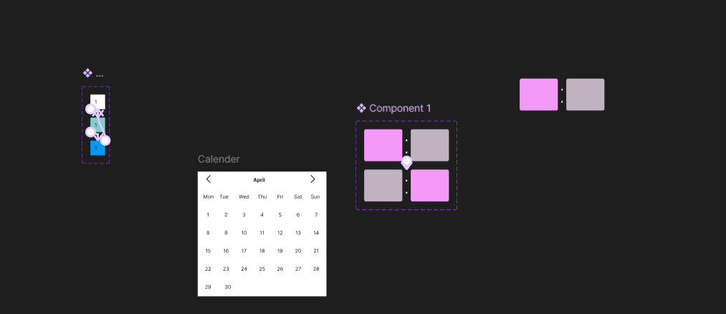

● ***User Flow Diagram:***

* **Step 1**: User writes a message.
* **Step 2**: Long-pressing the **Send** button opens a **"Schedule Message"** option.
* **Step 3**: User selects a **date (calendar)** and **time (AM/PM picker)**.
* **Step 4**: User taps **“Schedule”** and then **Send**.
* **Step 5**: The message appears in the chat with a **clock icon**.
* **Step 6**: Long-pressing the message shows **Info**, **Copy**, **Pin**, etc.
* **Step 7**: Tapping **Info** shows the status of the scheduled message (e.g., “Scheduled”), and updates to

● ***Prototyping Features Used in Figma:***

* ***Interactive Components****:*
* Calendar Date Picker
* Hour/Minute/AM-PM Time Picker
* **Smart Animation** for transitions between steps
* **Message Status Screens**:
* Clock icon overlay on messages
* Info panel mockup showing status updates

**III.Flight mode**

### **● Overview of the New Design:**

The newly designed Airplane Mode feature for WhatsApp introduces essential functionality aimed at providing users with more control over their connectivity without needing to disable their device’s entire network. The feature allows users to temporarily disable internet access only for WhatsApp, ensuring no messages are sent or received during the period.

#### **Key Features:**

* **In-App Airplane Mode Toggle**: A dedicated toggle in the app’s settings to enable or disable airplane mode specifically for WhatsApp.
* **Custom Duration Option**: Users can select a time frame (e.g., 15 minutes, 1 hour, or custom) during which WhatsApp remains disconnected.

**Benefits**:

* Helps reduce distractions without affecting other app functionalities.
* Encourages digital wellbeing and focus.
* Offers privacy during meetings, study sessions, or personal downtime

**● Wireframes & Mockups:**

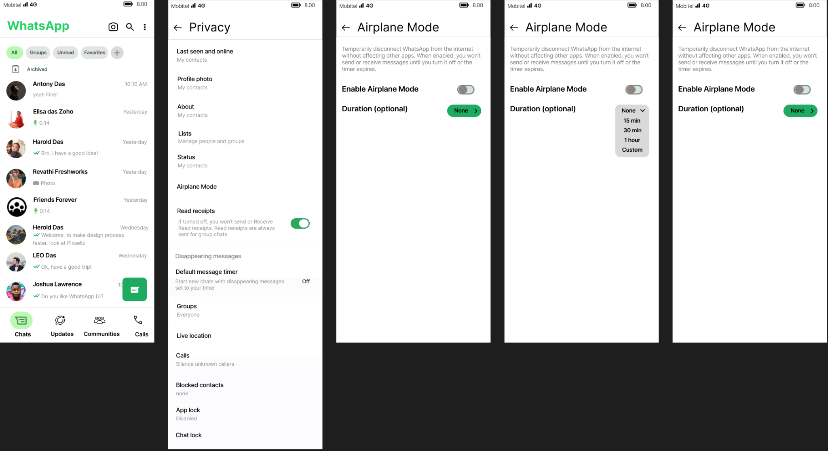

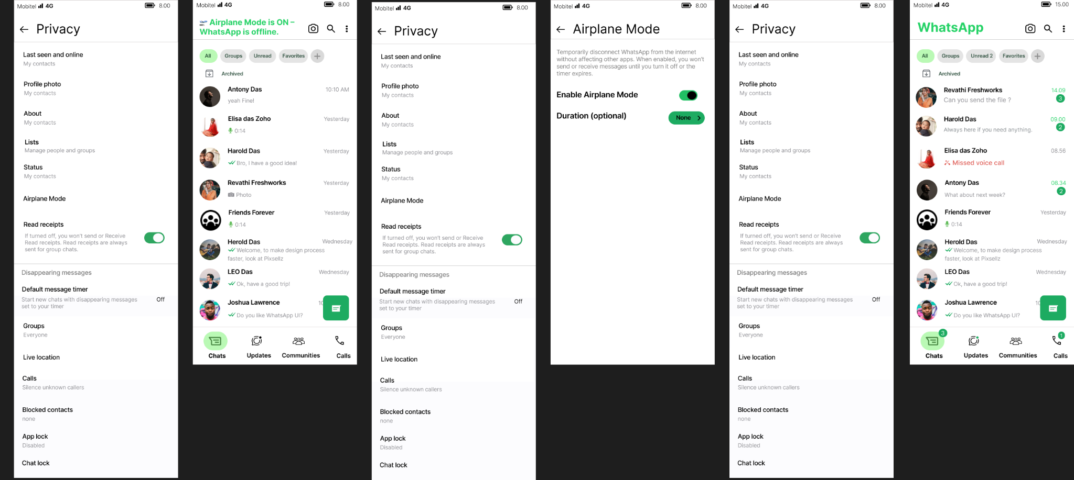

### **● User Flow Diagram:**

#### User Journey for Activating Airplane Mode:

* Open WhatsApp
* Go to **Settings**
* Tap **Airplane Mode**
* Toggle **Enable Airplane Mode**
* Select **Duration** (optional)
* Confirm activation  
   → WhatsApp disconnects from internet → Timer starts  
   → User can reconnect manually or wait for time to expire → App reconnects

#### User Journey for Receiving Messages During Airplane Mode:

* Contact sends a message  
   → Message is not delivered until mode ends  
   → Once reconnected, messages arrive with timestamp

### **● Prototyping Features Used in Figma:**

* Interactive Components:  
  Toggle switches for enabling/disabling Airplane Mode  
  Radio buttons and custom pickers for duration options
* Overlays:  
  Pop-up overlay to confirm activation and display remaining time
* Smart Animation:  
  Animated transitions from connected to disconnected state (e.g., grayed-out UI or banner indicating Airplane Mode)
* Device Frames:  
  iOS and Android mobile mockups used to visualize the feature realistically
* Prototype Links:  
  Connected screens simulate full user flow for testing and feedback gathering

**IV.Active status**

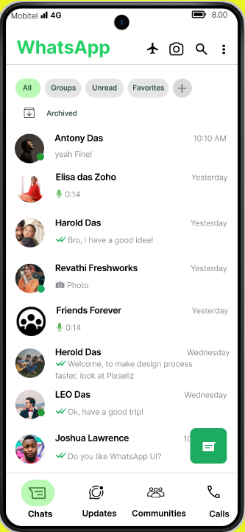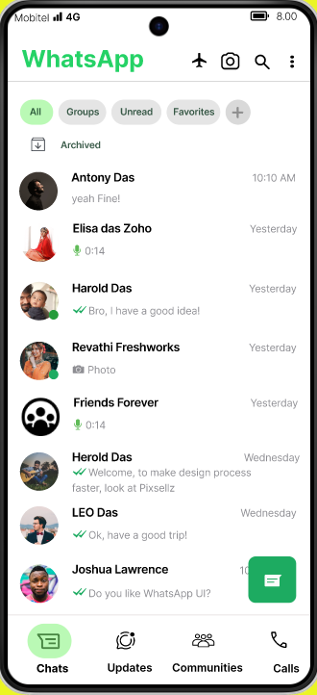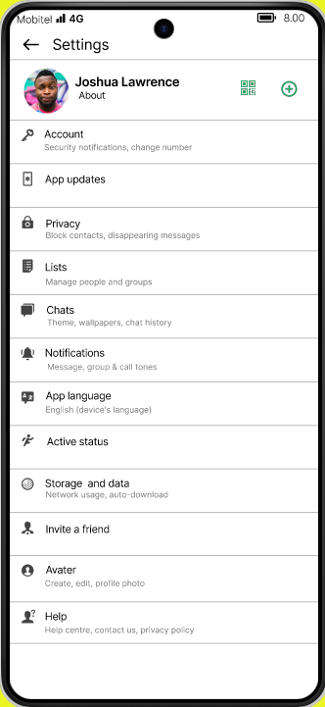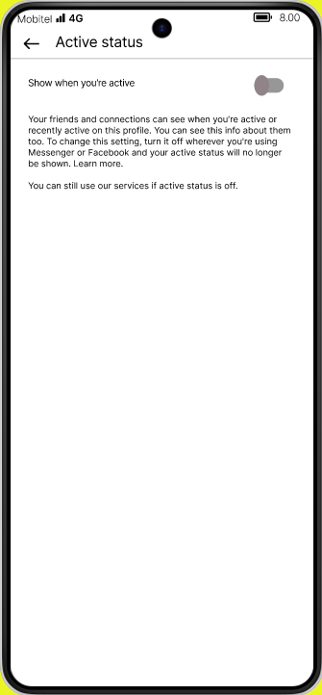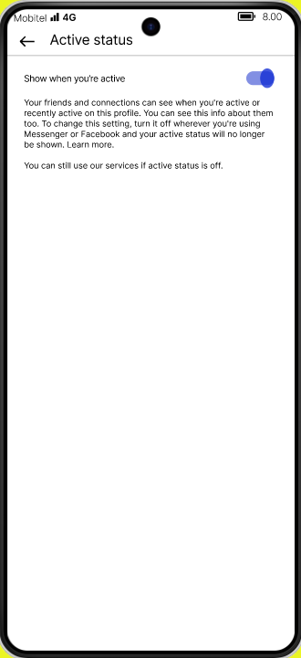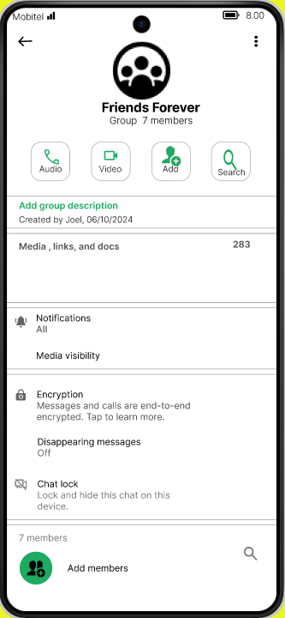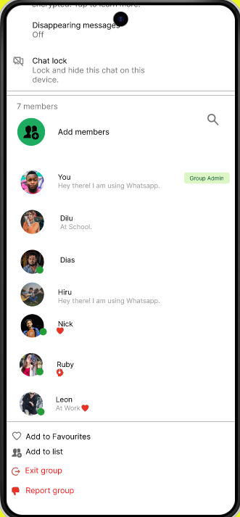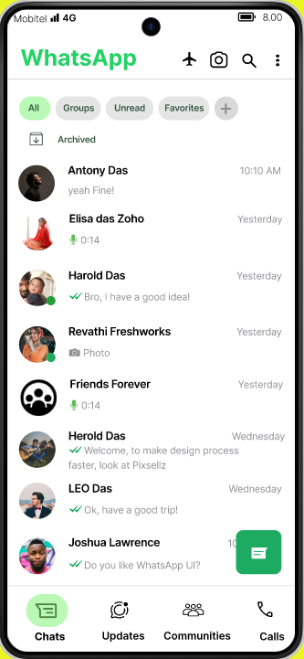

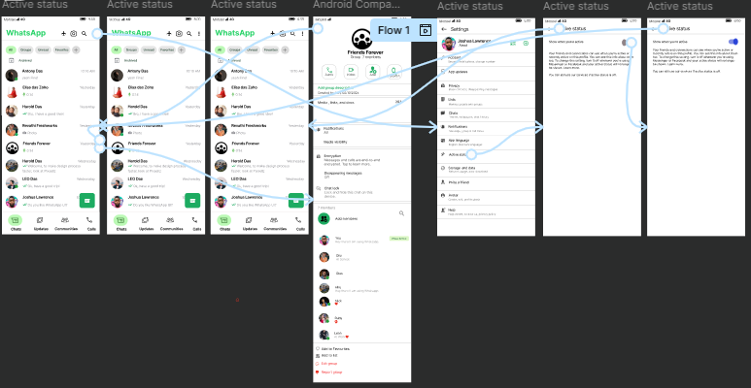

**V.Ghost mode**

● ***Overview of the New Design:***

*The* ***Ghost Mode*** *redesign focuses on enhancing* ***user control****,* ***privacy****, and* ***visibility of system status****. This feature allows users to become "invisible" on WhatsApp by hiding their* ***Last Seen****, preventing* ***read receipts*** *(blue ticks), and enabling* ***private status viewing****.*

*Key design elements include:*

1. ***Ghost Icon****: A ghost-shaped icon located at the top right corner of the home screen, next to the search icon, makes the feature easily discoverable (aligns with visibility and affordance).*
2. ***One-Tap Activation****: When the user taps the ghost icon, a popup appears explaining the Ghost Mode feature. Two buttons are provided:* ***Activate*** *and* ***Cancel****, supporting user control and freedom.*
3. ***Manual Deactivation****: Ghost Mode remains active until the user taps the ghost icon again to turn it off. This provides full control to the user over when to enable or disable the feature.*
4. ***Status Feedback****: When Ghost Mode is active, a visual indicator (e.g., a glowing or highlighted ghost icon) shows the user that the mode is on, aligning with visibility of system status.*
5. ***Effects****: While Ghost Mode is active:*
   * *Last Seen is frozen.*
   * *Read receipts are disabled (messages stay as a single tick).*
   * *Users can view others' status updates without being seen.*

*This redesign improves* ***user experience*** *by offering more* ***privacy options*** *without altering the core WhatsApp interface, aligning with HCI principles like* ***user control and freedom****,* ***consistency****, and* ***visibility of system status****.*

● ***Wireframes & Mockups:***

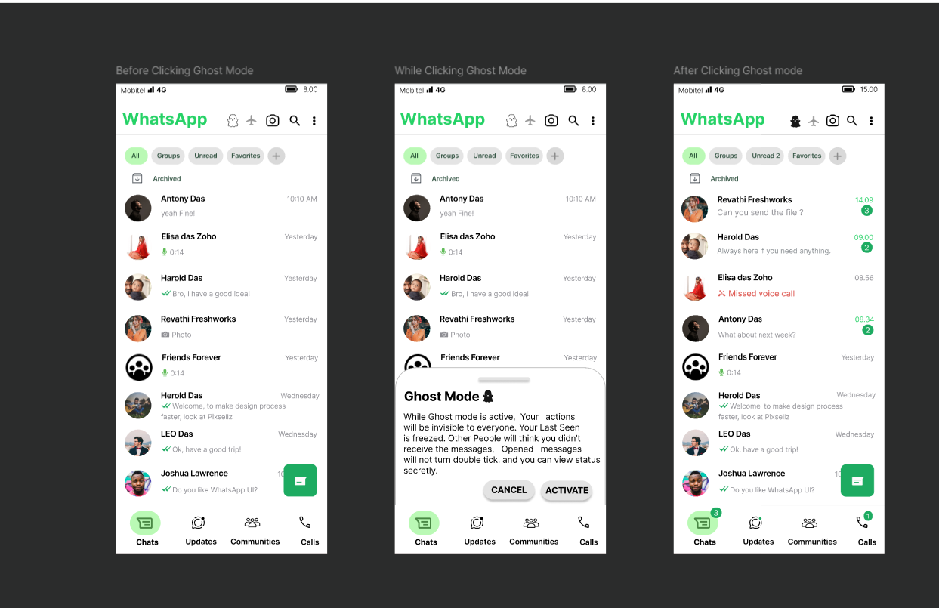

● ***User Flow Diagram:***

1. **Start Screen**: The user opens WhatsApp and notices the ghost icon next to the search bar.
2. **Tapping the Icon**: User taps on the icon to open a description popup explaining what Ghost Mode does.
3. **Activation Screen**: The user clicks on the **Activate** button to turn on Ghost Mode, or taps **Cancel** to exit.
4. **Active State**: Once activated, the system shows the "Invisible" status and freezes "Last Seen" and "Read Receipts."

● ***Prototyping Features Used in Figma:***

* **Interactive Components:**
* **Toggle Buttons:** The "Activate" and "Cancel" buttons in the Ghost Mode description window allow users to interact with the system.
* **Ghost Icon**: The icon changes states based on whether Ghost Mode is active or inactive (e.g., a subtle animation or color change to show activation).

## 

## 

## 

## 

## 

## ***6. Evaluation & Testing***

## **I. Scheduled Message Feature**

| Heuristic | Issue Identified | Recommendation |
| --- | --- | --- |
| Visibility of System Status | Users don’t know when a scheduled message will be sent or its delivery status. | Show a clock icon on the message until it is sent. Update with ticks after delivery. |
| User Control & Freedom | Users might want to cancel or reschedule messages. | Add options to edit or cancel scheduled messages by long-pressing them. |
| Match Between System and Real World | The scheduling interface might be confusing or inconsistent with mobile OS standards. | Use familiar iOS/Android date-time picker styles. |

## **II. Poll Feature (Time-Limited & Anonymous Polls)**

| Heuristic | Issue Identified | Recommendation |
| --- | --- | --- |
| Flexibility & Efficiency of Use | No way to close polls automatically or make votes anonymous. | Add poll expiration time and anonymous toggle before publishing. |
| Error Prevention | Users might vote without knowing votes are public. | Include a clear label indicating anonymity before submitting the vote. |
| Recognition Rather than Recall | Voters might not remember if the poll was anonymous or not. | Show an icon or label indicating poll mode at all times. |

## 

## 

## 

## **III. Ghost Mode**

| Heuristic | Issue Identified | Recommendation |
| --- | --- | --- |
| Privacy and Control | Users want to freeze last seen, read receipts, and status views simultaneously. | Allow a one-tap Ghost Mode toggle to enable all stealth features. |
| Match Between System and Real World | Behavior might feel unclear if ticks don’t update. | Provide short onboarding or tooltip explaining Ghost Mode effects. |
| User Control & Freedom | No temporary or timed Ghost Mode option. | Include a timer or “turn off after 1 hour” toggle. |

**IV. Flight Mode**

| Heuristic | Issue Identified | Recommendation |
| --- | --- | --- |
| Visibility of System Status | Users may not realize whatsapp is offline | Show **banner**, **airplane icon**, and **timer indicator** during Airplane Mode |
| Match Between System and Real World | Behavior might feel unclear if ticks don’t update. | Add a **duration/timer toggle** (e.g., “Turn off in 30 min”) |
| Help Users Recognize, Diagnose, Recover from Errors | User might think the app is broken if message do not send | Add a **short explanation**  **🛫 Airplane Mode is ON – WhatsApp is offline.** |
| Help & Documentation | New users may not understand the feature | Describe how airplane works in the particular page |
| Recognition Rather Than Recall | No clear way to check current mode status | Keep **Airplane icon visible** at the top of chat screen or home tab |

## 

## 

## 

## 

## 

## 

## **V. Active Status**

| Heuristic | Issue Identified | Recommendation |
| --- | --- | --- |
| Visibility of System Status | Users currently have no way to see who’s online without opening chats. | Show a small green dot on the bottom-right of the profile picture in chat list, group list, and status viewer. |
| User Control & Freedom | Users may want to hide their online status selectively. | Include settings to choose visibility: 'Everyone / My Contacts / Nobody / Custom'. |

● ***Limitations & Future Improvements:*** *(Any constraints or additional refinements needed)*

## 

## 

## 

## 

## 

## 

## 

## 

## 

## ***7. Conclusion***

● ***Final Thoughts on the Redesign:*** *(Summary of key takeaways from the project)*

As a group, we redesigned WhatsApp by adding new features like **Scheduled Messages**, **Poll Time Limits and Anonymous Voting**, **Ghost Mode**, **Flight Mode**, and **Active Status (green dot)**. These features were created to improve user privacy, make the app more efficient, and give users more control. We made sure each new feature fits well with WhatsApp’s original design so that users can use them easily without confusion.

● ***How HCI Theory Helped:*** *(Reflection on how Alan Dix’s and Preece-Rogers-Sharp’s HCI and ID principles were applied)*

We used Human-Computer Interaction (HCI) principles from **Alan Dix** and **Preece, Rogers, and Sharp** to guide our design decisions. These principles helped us focus on providing **clear system feedback**, giving users **more control**, and making sure the features feel **familiar and easy to use**. We aimed to create designs that matched what users already know from other apps, used simple and recognizable patterns, and ensured each feature was easy to understand without extra instructions.

● ***Lessons Learned:*** *(What did you learn from this exercise?)*

Through this project, we learned how important **teamwork**, **user-focused design**, and **HCI principles** are when building features. We saw that even **small changes**, like a new icon or a pop-up option, can make a big difference in how users interact with the app. We also learned how to turn real problems users face into useful design solutions.

### ***8. References if used any***

***9. Contribution***

| **Team Member** | **Contributions** |
| --- | --- |
| EUSL/TC/IS/2021/COM/34 | Scheduling Messages |
| EUSL/TC/IS/2021/COM/48 | Active status |
| EUSL/TC/IS/2021/COM/61 | Ghost Mode Report,Active status |
| EUSL/TC/IS/2021/COM/71 | Anonymous Poll And Poll Limitation |
| EUSL/TC/IS/2021/COM/75 | Airplane Mode |
| EUSL/TC/IS/2021/COM/93 | Ghost Mode |

### ***Appendices (If applicable)***

● ***User Feedback Surveys*** *(If any usability tests were conducted)*

● ***Additional Design Mockups*** *(Alternative design approaches explored in Figma)*